Manila Water Company
technical specification - ENHANCEMENT
DID_R2R_211
Interest Rates Bottler

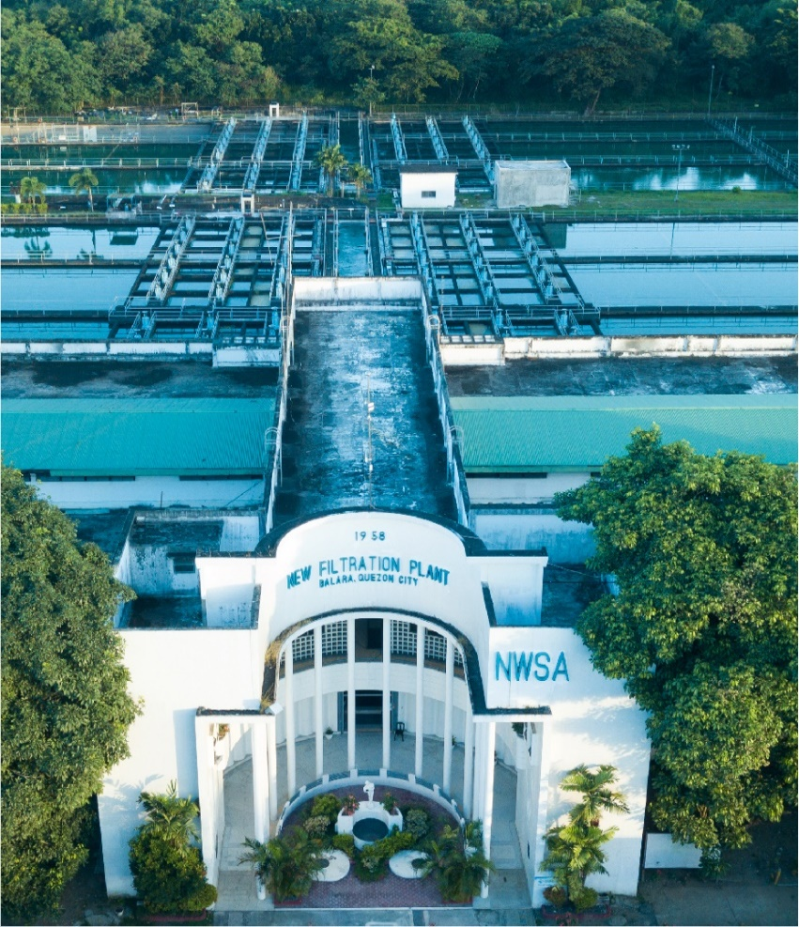



Contents
1 Document Organization 5
1.1 Document Log 5
1.2 Integration, Document Reference 5
2 Program Attributes 6
2.1 Selection Screen 6
2.2 Validation of Selection Criteria 7
2.3 CDS Views/AMDP/Table Function 7
2.3.1 Selection Condition 7
2.3.2 Join Condition 7
2.3.3 Fields 7
2.3.4 Additional Details 7
2.3.5 GIT Repository Details 7
2.4 Authorization Requirements 8
2.4.1 Definition 8
2.4.2 Defined Fields 8
2.4.3 Procedure 8
2.4.4 DCL Details 8
2.4.5 BTP Details 8
2.5 Technical Flow Diagram 8
2.6 UI Details 8
2.6.1 UI Mock Screens 8
2.6.2 Navigations 9
2.6.3 Actions 9
2.6.4 Validations 9
2.6.5 Other Details 10
2.7 Processing Logic 10
2.8 Reusable Code 10
2.9 Messages 10
2.10 Subroutines 11
3 Report Output 11
3.1 Output Method 11
3.2 Main Heading 11
3.3 Sub Heading 11
3.4 Layout / UI Design 11
3.5 Totaling 12
3.6 Sorting 12
3.7 Page Break 12
3.8 Error Handling 12
3.9 Report Header & Footer 12
4 Assumptions in Technical Design 12
5 Open Issues in Technical Design 12
6 Unit Test Results 12
7 Related Documentation 13

Document Organization
This section provides details about this document, previous version(s) of this document and the document(s) referred.

Document Log
Following table mentions the version changes and the processer(s):
Version | Status | Date | Version Created by (Name/E-Mail/Company) | Role | Comments
 | Draft | April 13, 2025 | Vipul Tamboli | Author

Integration, Document Reference

S. No. | Referred Document Name | Referred Document Version | Referred Document URL (Optional)
N/A | N/A | N/A | N/A

Program Attributes
Program title | Interest Rate Bottler
Program Name | ZAB_R2R_FTR_FX_COMPBID  ZAB_R2R_FOREIGN_EXCHANGE  ZAB_R2R_TMCB_EDIT  ZAB_R2R_TMCC_DISPLAY
Program Type | Executable
Package | ZS4_MWC_R2R_TRM
Authorization Group | N/A

Transaction Code | ZTRM_OFR_FD_CRT  ZTRM_OFR_EDIT  ZTRM_OFR_DISPLAY  ZTRM_OFR_FX_CRT
Include Programs | ZIN_FG_R2R_FTR_MMO01  ZIN_FG_R2R_FTR_MMF01  ZIN_FG_R2R_FTR_MMI01  ZIN_FTR_MMF01  ZIN_FTR_MMO01
Function Modules | DATE_STRING_CONVERT  F4IF_INT_TABLE_VALUE_REQUEST  HR_JP_MONTH_BEGIN_END_DATE  BAPI_FTR_IRATE_DEALCREATE  ZAB_R2R_TMCC_DISPLAY

SAP Tables Read | TZDEA  VTBLS  VTBLV  VTBLIS  VTBFHA  VTBFHAPO
Custom Tables | ZDT_TRM_RATESBT
Custom Indexes | N/A
CDS Views | N/A
OData Service | N/A
Business Object | N/A
Group Name | N/A
Catalog Name | N/A

Screens
- ZTRM_OFFERS_CRT.
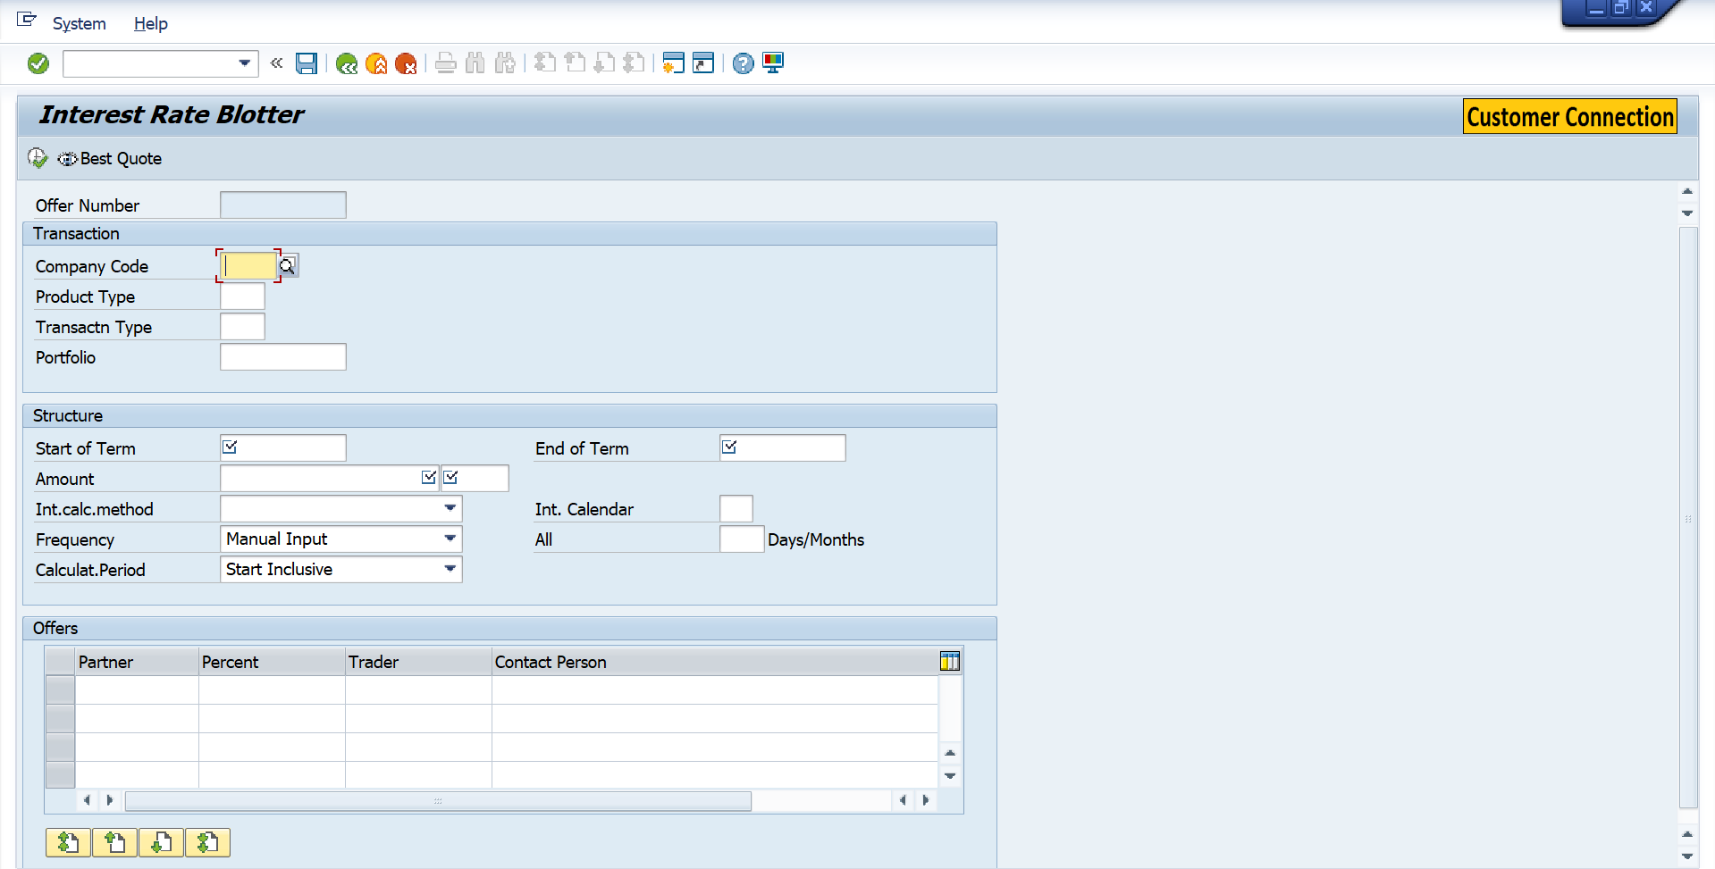

- ZTRM_FOREX_CRT
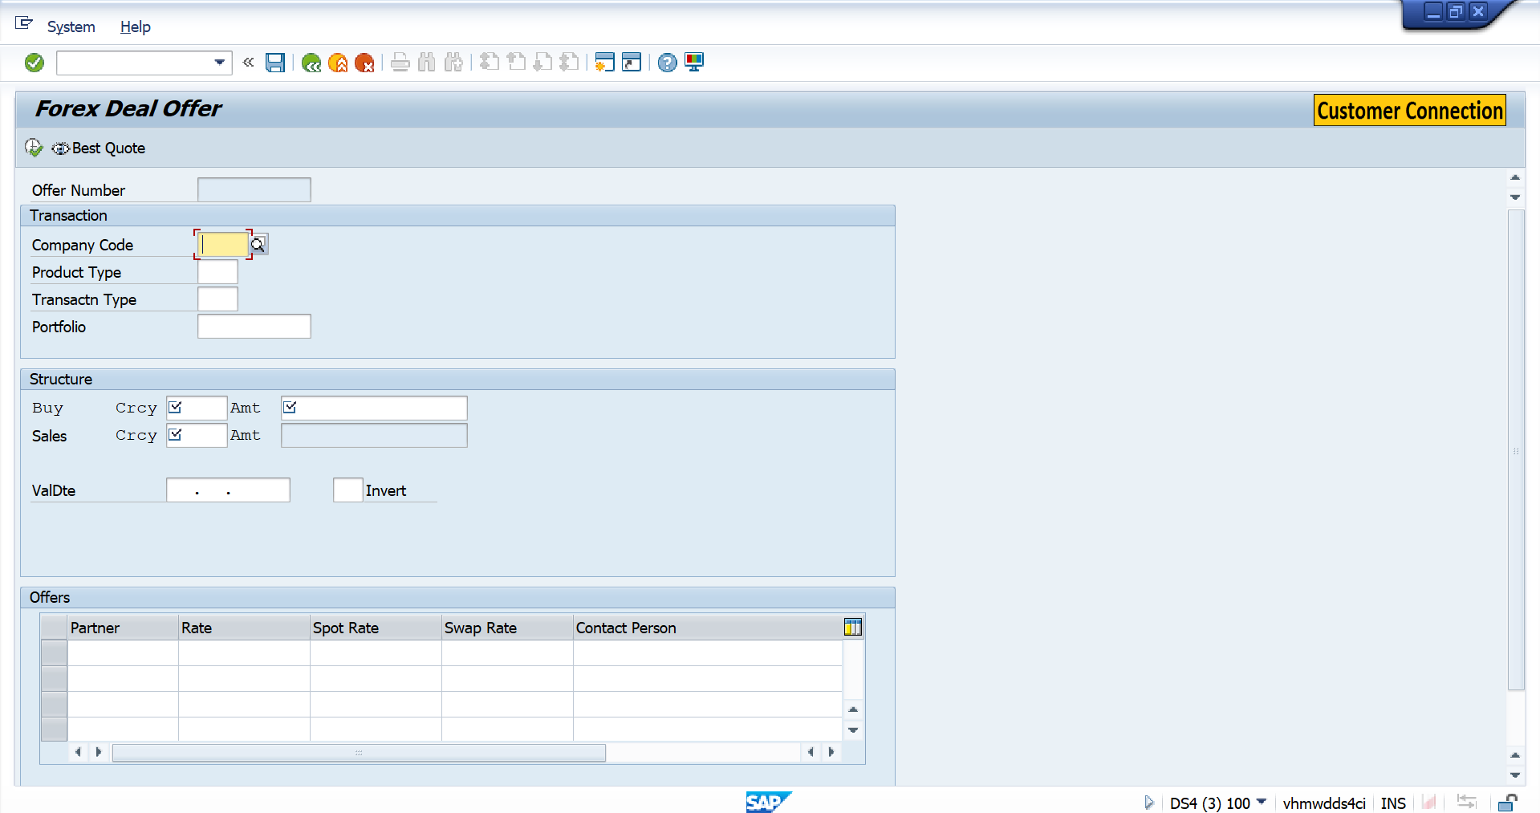

- ZTRM_OFFERS_EDIT.
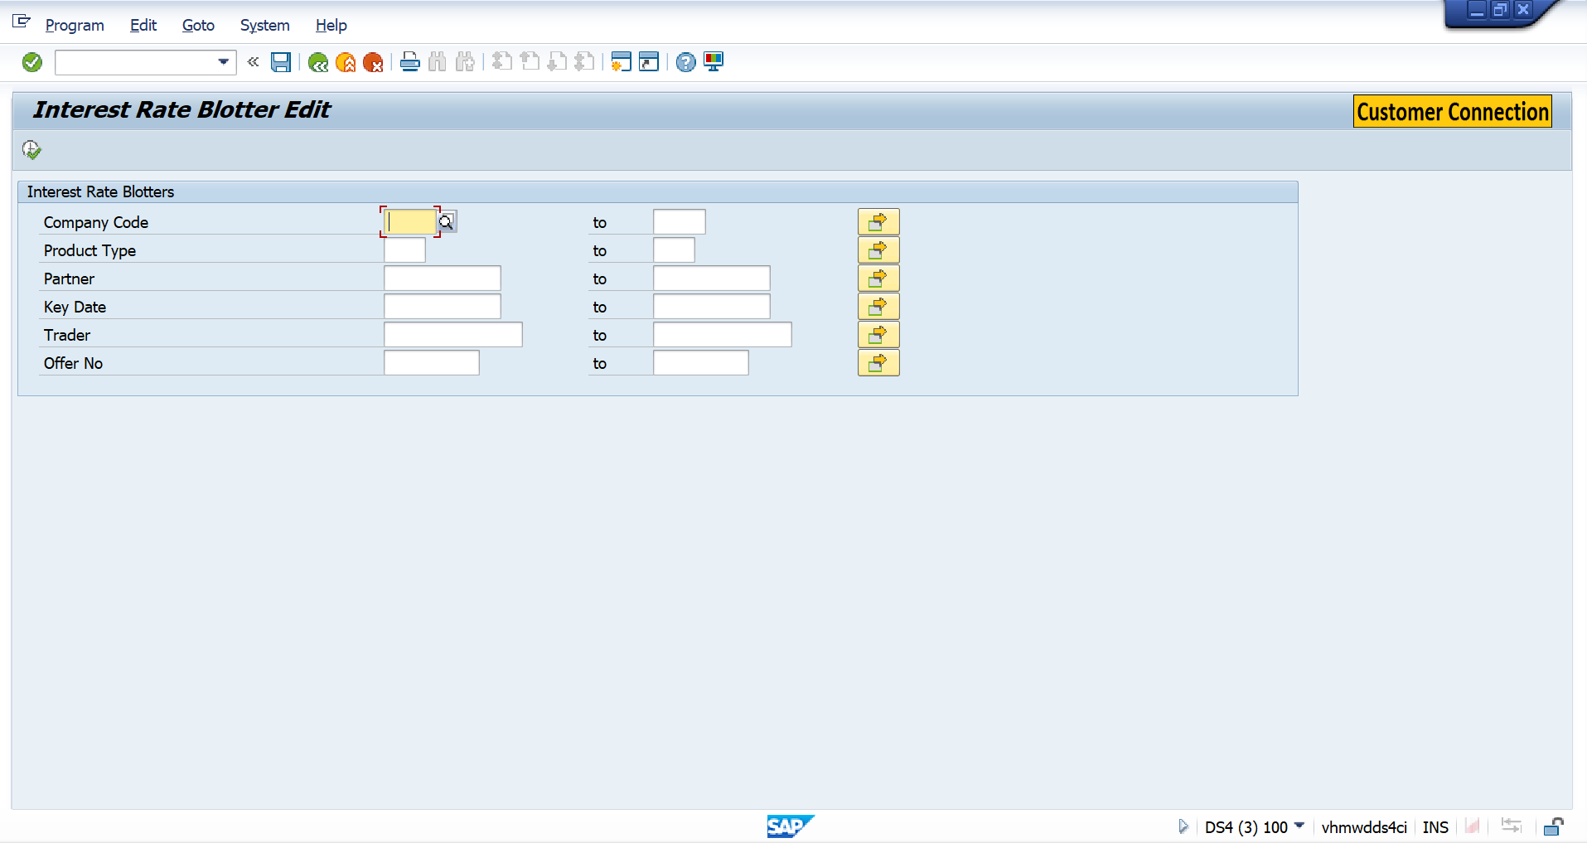

- ZTRM_OFFERS_DSP
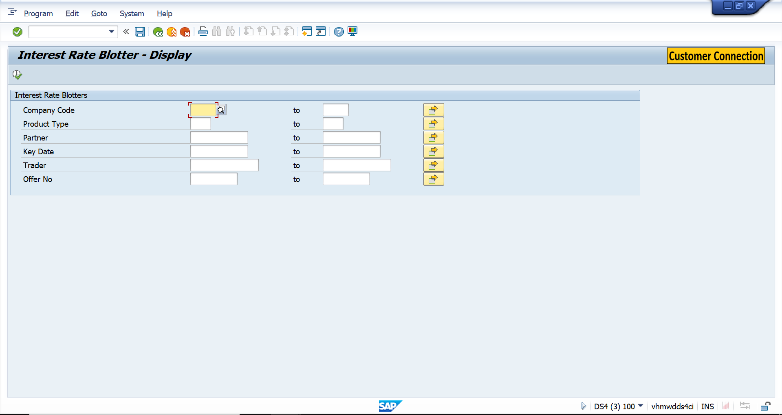

Validation of Selection Criteria
- ZTRM_OFFERS_CRT.
- Company Code
- Product Type
- Transaction Type
- Amount
- Currency
- Dates (Value Date, Maturity Date, etc.)
- Interest Calculate Method

- ZTRM_FOREX_CRT
- Company Code
- Product Type
- Transaction Type
- Buy Currency
- Sale currency
- Value Date

- ZTRM_OFFERS_EDIT.
N/A

- ZTRM_OFFERS_DSP
N/A

CDS Views/AMDP/Table Function
N/A

Selection Condition
N/A

Join Condition
N/A

Fields

N/A

Additional Details
N/A

GIT Repository Details

Development Details
GIT Location | N/A
GIT URL | N/A

Authorization Requirements
N/A

Definition
N/A

Defined Fields
N/A

DCL Details
N/A

BTP Details

xs-security Configuration | N/A
IDP Setup | N/A
BTP Role Collections | N/A

Technical Flow Diagram
- ZTRM_OFFERS_CRT.

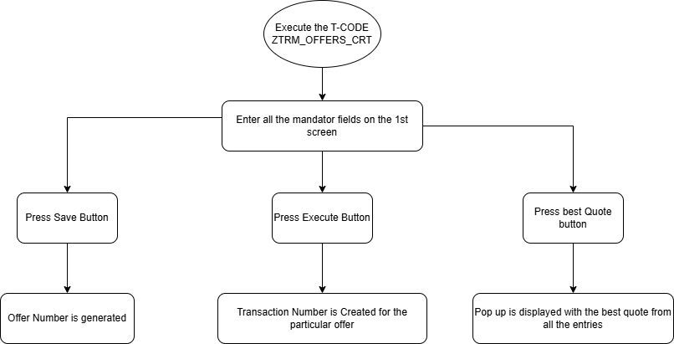

- ZTRM_FOREX_CRT
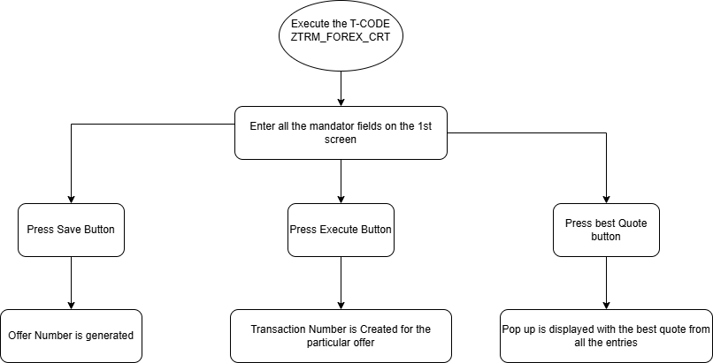

- ZTRM_OFFERS_EDIT.
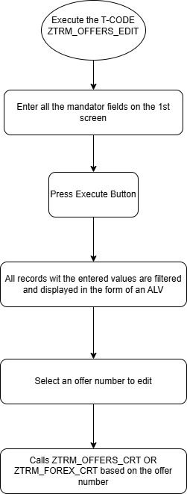

- ZTR_OFFERS_DSP.

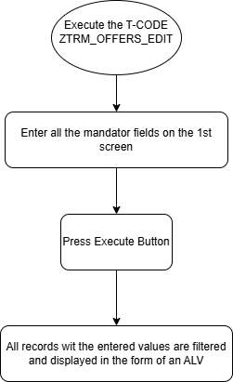

UI Details
N/A

UI Mock Screens

Application Name
Site | N/A
URL | N/A
Mockup | N/A

Navigations

Source View | Target View / URL | Pattern
N/A | N/A | N/A

Actions

Application | Screen(s) | Action | Type | Action Description
N/A | N/A | N/A | N/A | N/A

Validations
Application | Screen(s) | Field/Button | Validation Logic – Method, function details
N/A | N/A | N/A | N/A

Other Details
N/A

Processing Logic
- ZTRM_OFFERS_CRT.
1.1. Enter the mandatory fields on the input screen
- Fields include: Company Code, Product Type, Transaction Type, Amount, Currency, Dates etc.
1.2. Press the "Save" button
- A new Offer Number is generated
1.3. Click the "Best Quote" button
- The system reads available offers from the internal table.
- Applies best quote selection logic
- A popup is displayed showing the best quote found.
1.4. Select one record from the list
- The selected offer is highlighted for execution.
- Only one offer can be selected for further processing.
1.5. Press the "Execute" button
- Calls BAPI_FTR_IRATE_DEALCREATE.
- If successful:
  - A Transaction Number is generated
  - Confirmation message is displayed to the user

- ZTRM_FOREX_CRT
2.1. Enter the mandatory fields on the input screen
- Fields include: Value Date, Amount, Buy Currency, etc.
2.2. Press the "Save" button
- A new Offer Number is generated
2.3. Click the "Best Quote" button
- The system reads available offers from the internal table.
- Applies best quote selection logic
- A popup is displayed showing the best quote found.
2.4. Select one record from the list
- The selected offer is highlighted for execution.
- Only one offer can be selected for further processing.
2.5. Press the "Execute" button
- Calls BAPI_FTR_FXT_DEALCREATE.
- If successful:
  - A Transaction Number is generated
  - Confirmation message is displayed to the user

- ZTRM_OFFERS_EDIT.
3.1. Enter the search criteria on the selection screen
- Fields may include: Company Code, Product Type, Currency, etc.
3.2. Press the "Execute" button
- The system reads matching records from the custom table ZDT_TRM_RATESBT.
- Matching offers are displayed in a list/table format on the output screen.
3.3. Click on any Offer Number in the list
- The system navigates to the Edit screen.
- All relevant data for the selected offer is pre-filled in the input fields.
3.4. Modify the required fields
- Fields can be updated.
- Some fields may be read-only based on offer status or validations.

- ZTRM_OFFERS_DSP.
4.1. Enter the search criteria on the selection screen
- Fields may include: Company Code, Product Type, Currency, etc.
4.2. Press the "Execute" button
- The system reads matching records from the custom table ZDT_TRM_RATESBT.
- Matching offers are displayed in a list/table format on the output screen.

Reusable Code
N/A

Messages
N/A

Subroutines
Name | Description
N/A
N/A
N/A

Report Output

Output Method

Main Heading

Sub Heading
N/A

Layout / UI Design
N/A

Totaling
N/A

Sorting
N/A

Page Break
N/A

Error Handling
N/A

Report Header & Footer
N/A

Assumptions in Technical Design

N/A

Unit Test Results

Scenario # | Input Selection Criteria | Expected Result | Actual Test Pass/Fail
1 | Create, edit and display offer for placements. | Offer created with applicable bids.  Details stored in the database table for subsequent reporting.  Edit or display the offer. | Pass
2 | Create, edit and display offer for forex. | Offer created with applicable bids.  Details stored in the database table for subsequent reporting.  Edit or display the offer. | Pass

Related Documentation

Template Version
Version | Status | Date | Version Created by (Name/E-Mail/Company) | Role | Comments
1.0 | Final | February 11, 2019 | Sweety | Author
1. | Final | March 15, 2022 | Sweety | Author | Updated to accommodate details of Fiori/UI5 Application related artifacts using ABAP programming model for SAP Fiori Elements

